**Week-3**

**Task-2**

**Lab 2: Setting Up the Database Context for a Retail Store**

using RetailStoreApp;

using RetailStoreApp.Models;

class Program

{

static void Main()

{

using var context = new RetailContext();

// Add product

var product = new Product

{

Name = "Notebook",

Quantity = 50,

Price = 89.99m

};

context.Products.Add(product);

context.SaveChanges();

// Read and display

var products = context.Products.ToList();

foreach (var p in products)

{

Console.WriteLine($"Product: {p.Name}, Quantity: {p.Quantity}, Price: {p.Price}");

}

}

}

**Output**

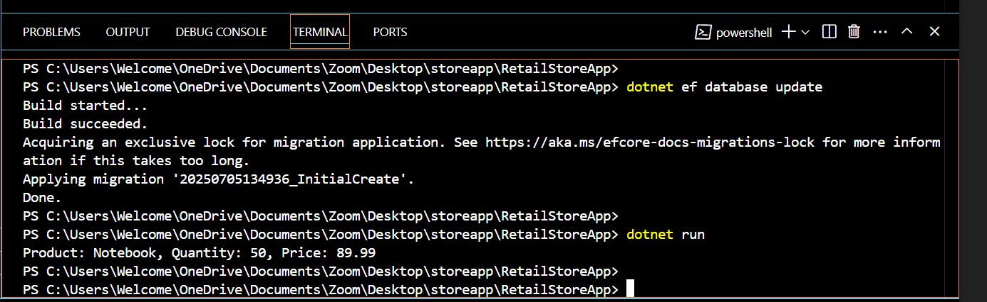

**Name:Ayushman Upadhyay**

**Email:2230164@kiit.ac.in**

**Superset Id: 6358125**